COL (Ret) Princess Facen
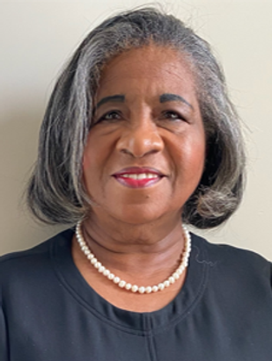
NABMW Executive Board Elected Position: President, March 2021-Present
Rank: Colonel
SSI (Officers): 66H 8A/Nurse Officer
Military Branch: Army
Time in Service: 1981-2009 (28 years)
Personal History: Colonel (Ret) Princess Facen was born in Hampton, VA and entered the military as a Captain. She was the Senior Reviewing Officer for her retirement ceremony held at FT. Myers, Virginia. She is married to COL (Ret) Wendell Stepp and have two daughters, Michelle and Rhonda. A graduate of Hampton University

Assignments: Most recent assignment after retirement was Chief, Education and Training, Vaccine Healthcare for the Defense Health Agency, Falls Church, Virginia, covering Conus and OConus military beneficiaries. Other assignments prior to retirement from the military include Critical Care Nurse, Surgical ICU and Staff Nurse Recovery Room, at Walter Reed Army Medical Center, Washington, DC; Staff Nurse ICU and Evening Supervisor at the 121st Evac Hospital Korea, Head Nurse Medical Unit , FT. Meade, MD, Medical Rotation to JTF- Bravo Honduras, Chief Nurse 129th Medical Detachment, Hanau Germany, Chief Hospital Education and Training Moncrief Army Community Hospital, FT Jackson, SC, Chief Nurse 1st ROTC Region, Fort Bragg, NC, Chief Nursing Administration, FT Stewart, GA, Chief Hospital Education and Training, FT Gordon, GA, Chief Nurse, 249th Combat Support Hospital in support of Task Force Med Eagle, Bosnia, Herzegovina, Director, Medical and Psychiatric Nursing Section and Director of Hospital Education, Walter Reed Army Medical Center, Washington, D.C.

Organization/Positions/Assignments in which you were a FIRST: 2005-2006, she acquired funding and support from The Pentagon Federal Credit Union Foundation and Gary Trudeau “Doonesbury” creator, to plan and stand up the multi-million dollars, first ever Palliative Care Suite in the military, for patients and family with Cancer to gather so they could spend precious moments together at the end of life, “Dying with Dignity”. She was the first Chief of Hospital Education and Training at Moncrief Army Community Hospital at FT Jackson, SC in 1992. She was also the first to bring Military Nurse instructors, from Thailand, to Walter Reed Army Medical Center to audit our Critical Care Nursing Program so they could replicate and implement similar in their country. Presented as a guest speaker at the international medical conference in Thailand in 2008

Deployments: Honduras; Bosnia,

Awards: Awards and decorations include: Legion of Merit, Meritorious Service Medal (5 OLC), Army Commendation Medal (5OLC), Army Achievement Medal (1OLC), Army Superior Unit Award, National Defense Service Medal, Armed Forces Expeditionary Medal, Global War on Terrorism Service Medal, Korean Defense Service Medal, Army Service Ribbon, Overseas Service Ribbon (2OLC), NATO Medal, and Armed Forces Reserve Medal. She is the recipient of the Order of Military Medical Merit.

Other Professional Affiliations: Charter Member: National Museum of African American History; Charter Member and first President of the DMV-National Association of Black Military Women Chapter; Life Member, Rocks, Inc.; Member Walter Reed Society, Army Nurse Corp Association, Sigma Theta Tau, Links, Inc Executive Director, White Rose Foundation, Prince Georges County, Member, Women in Military Service for America, Member, National Council of Negro Women; Member Hampton University Nurses Alumni Chapter.
Contact
President

